LLM-RAG based startup idea feasibility and market validation engine

Abstract:
In the rapidly changing startup environment, evaluating a new business idea is difficult because market demand, customer expectations, competitor activities, pricing, technology trends, and industry conditions can change within a short period. Traditional validation methods often depend on manual research, historical datasets, or isolated sources, making the assessment time-consuming and potentially outdated. To address these challenges, this project proposes an LLM-RAG Based Startup Idea Feasibility and Market Validation Engine that combines real-time information retrieval, Retrieval-Augmented Generation (RAG), and multi-agent artificial intelligence. The system collects relevant and recent information from market sources, government datasets, research publications, customer feedback, news, and competitor information. The RAG component retrieves the most relevant evidence from the collected knowledge base and provides it to a large language model for context-based analysis. Specialized agents independently examine market demand, customer pain points, competitors, market gaps, technical feasibility, business potential, and associated risks. A scoring mechanism then combines these factors to generate an overall feasibility score, while evidence confidence is used to indicate the reliability of the assessment. Based on the findings, the system provides an actionable recommendation, such as developing the idea, modifying it, performing further validation, or reconsidering it. The proposed approach aims to provide a faster, transparent, evidence-based, and continuously updateable solution for startup idea evaluation and market validation.

Keywords:
Large Language Model (LLM), Retrieval-Augmented Generation (RAG), Startup Feasibility Analysis, Market Validation, Real-Time Market Intelligence, Multi-Agent AI, Competitor Analysis, Customer Pain-Point Detection, Market Gap Detection, Evidence-Based Decision Support, Feasibility Scoring, Explainable AI

INTRODUCTION

The startup ecosystem is highly dynamic, competitive, and influenced by continuous changes in customer preferences, market demand, technology, pricing, competitor strategies, and industry conditions. A new business idea may appear promising at an initial stage, but its actual feasibility depends on whether a genuine customer problem exists, whether sufficient market demand is present, whether competitors already provide similar solutions, whether an identifiable market gap exists, and whether the proposed solution can be implemented using available technologies. Therefore, systematic startup idea evaluation and market validation are important before investing significant financial, technical, and human resources. The project document identifies these challenges and highlights that traditional validation methods may depend on manual research, historical datasets, or isolated information sources, making the process time-consuming and potentially outdated.
Traditional startup evaluation approaches generally examine business characteristics, market conditions, competitors, financial information, and historical startup data. Although these approaches can provide useful information, they may not sufficiently represent rapidly changing market conditions. Customer expectations can change quickly, new competitors can enter a market, existing companies can introduce new features, and technological developments can create new opportunities or risks. Consequently, an evaluation based mainly on older or limited information may not accurately represent the current feasibility of a startup idea. The existing-system analysis in the project identifies dependence on historical or limited data, unsupported conclusions from general-purpose LLMs, limited customer pain-point and market-gap analysis, and the absence of easily understandable evidence-based feasibility recommendations as important limitations.
Recent developments in Large Language Models (LLMs) provide new opportunities for analyzing large amounts of unstructured information. Transformer-based architectures have significantly improved natural-language understanding and generation, while modern LLMs can process complex textual inputs and generate human-readable analytical responses. However, an LLM working only from its internal knowledge may not have access to the latest market information and may generate unsupported statements. Research on Retrieval-Augmented Generation (RAG) addresses this limitation by combining language generation with retrieval from external knowledge sources. The original RAG framework combines a language model with non-parametric external memory, allowing relevant information to be retrieved and incorporated into generation.
The proposed project applies this concept specifically to startup feasibility and market validation. Instead of depending only on the internal knowledge of an LLM, the system retrieves relevant evidence related to the submitted startup idea. The collected evidence can include market information, customer feedback, competitor information, research publications, news, government datasets, and other relevant sources. The retrieved information is then supplied to the LLM so that the generated analysis is grounded in supporting evidence. The project uses Sentence Transformers for semantic representation and ChromaDB for storing and retrieving relevant evidence. Sentence-BERT is particularly useful for semantic similarity and efficient sentence-level retrieval, making embedding-based retrieval suitable for a system that must identify information related to a user's startup idea.
Another important feature of the proposed system is its multi-dimensional analysis. Startup feasibility cannot be determined from a single factor. The implemented system therefore separates the analysis into different modules, including Startup Idea Input, LLM-RAG Analysis, Market Analysis, Customer Pain Analysis, Competition Analysis, Market Gap Analysis, Technical Feasibility, Validation Score, and Final Validation Report. These modules allow the system to examine the target market, relevant problems, customer pain points, competitors, unresolved market problems, technical requirements, technical risks, and evidence strength.
The Market Analysis module identifies market evidence, supporting sources, the primary market, and relevant markets. The Customer Pain Analysis module identifies pain points, categories, severity, and supporting evidence. The Competition Analysis module examines the competitive landscape and available competitors, while the Market Gap Analysis module focuses on unresolved problems and potential opportunities. The Technical Feasibility module additionally considers technical requirements, technical signals, technical risks, and implementation feasibility.
The information obtained from these analytical dimensions is converted into a quantitative validation score. Instead of providing only a textual opinion, the system displays individual dimension scores together with an overall validation score and validation potential. The dashboard provides a visual comparison of the different validation dimensions, helping users understand where a startup idea performs strongly or where additional validation may be required. This makes the system more understandable and useful for decision support.
Finally, the system generates a consolidated Startup Validation Report containing the startup idea summary, target market, customer pain points, market evidence, validation score, evidence-based recommendation, and evidence limitations. The recommendation can help users decide whether to continue developing the idea, modify the proposed solution, conduct additional validation, or reconsider the idea. Thus, the proposed LLM-RAG based Startup Idea Feasibility and Market Validation Engine aims to provide a faster, evidence-oriented, transparent, and continuously updateable approach to preliminary startup evaluation. It does not replace actual customer interviews, pilot testing, financial due diligence, or expert judgment; instead, it acts as an intelligent decision-support system that organizes available evidence and converts it into a structured feasibility assessment.

Objective of the project:

- To develop an LLM-RAG based startup evaluation system that accepts a startup idea and retrieves relevant information for feasibility and market validation.
- To analyze important startup factors such as market demand, customer pain points, competition, market gaps, technical feasibility, business potential, and associated risks using specialized analytical modules.
- To improve the reliability of LLM-generated analysis by retrieving relevant evidence from external information sources and providing that evidence as context to the language model.
- To generate a quantitative validation score and confidence-based assessment by combining the results obtained from different feasibility dimensions, allowing users to understand the overall potential of a startup idea.
- To provide an evidence-based final recommendation and validation report that clearly presents the strengths, weaknesses, opportunities, risks, supporting evidence, and limitations associated with the proposed startup idea.

LITERATURE SURVEY:
1. P. Lewis et al. (2020) – “Retrieval-Augmented Generation for Knowledge-Intensive NLP Tasks”

Lewis et al. introduced Retrieval-Augmented Generation (RAG), a framework that combines a pre-trained language model with an external non-parametric knowledge source. The study addresses the limitation of language models that store knowledge mainly within their parameters and may have difficulty accessing, updating, or precisely manipulating external information. The proposed RAG approach retrieves relevant passages from an external knowledge base and uses them together with the language model to generate responses. The researchers demonstrated that retrieval-augmented models can produce more specific, diverse, and factual responses than models relying only on parametric knowledge. This work is highly relevant to the proposed startup feasibility system because startup validation requires current information about markets, competitors, customers, technologies, and industry conditions. Instead of relying only on the internal knowledge of an LLM, the proposed system can retrieve relevant market evidence and provide it to the LLM for grounded analysis. The study therefore provides the fundamental technical foundation for using RAG to reduce unsupported responses and improve evidence-based startup evaluation.

2. N. Reimers and I. Gurevych (2019) – “Sentence-BERT: Sentence Embeddings using Siamese BERT-Networks”

Reimers and Gurevych proposed Sentence-BERT (SBERT), a modification of BERT designed to generate meaningful sentence embeddings that can be efficiently compared using similarity measures. Traditional BERT models are computationally expensive when large numbers of sentences must be compared because each pair needs to be processed through the network. Sentence-BERT addresses this problem by producing fixed-size sentence representations that can be compared efficiently. The method demonstrated strong performance on semantic textual similarity and information retrieval tasks. This research is relevant to the proposed startup validation engine because the system needs to identify information that is semantically related to a submitted startup idea. Market reports, customer reviews, competitor descriptions, research papers, and news articles may use different terminology while discussing the same concept. Sentence embeddings can therefore help retrieve semantically relevant evidence rather than relying only on exact keyword matching. SBERT provides an important foundation for the semantic retrieval component of the proposed LLM-RAG system.

3. Y. Gao et al. (2023) – “Retrieval-Augmented Generation for Large Language Models: A Survey”

Gao et al. presented a comprehensive survey of Retrieval-Augmented Generation techniques for Large Language Models. The study explains that although LLMs demonstrate strong language-generation capabilities, they face problems such as hallucination, outdated knowledge, and limited transparency. RAG addresses these issues by incorporating information retrieved from external knowledge bases. The survey categorizes RAG systems into different development stages, including Naive RAG, Advanced RAG, and Modular RAG, and discusses retrieval, augmentation, and generation components. This work is directly relevant to the proposed startup feasibility and market validation engine because the system depends on retrieving external evidence before generating its assessment. Startup information changes frequently, making external retrieval particularly important. The study supports the use of RAG as a mechanism for incorporating current and domain-specific information into LLM-based analysis.

4. J. Kim, H. Kim and Y. Geum (2023) – “How to Succeed in the Market? Predicting Startup Success Using a Machine Learning Approach”

Kim, Kim, and Geum developed a machine learning approach for predicting startup success by considering both internal startup characteristics and external industry characteristics. The study analyzed 218,207 companies from Crunchbase and compared six machine learning models for startup success prediction. The researchers found that factors such as media exposure, monetary funding, industry convergence, and industry association were significant in predicting startup success. This research demonstrates the value of combining multiple business and environmental factors when evaluating startups instead of relying on a single characteristic. The work is relevant to the proposed system because startup feasibility also depends on multiple dimensions, including market conditions, competition, customer requirements, technical feasibility, and business potential. However, the study primarily uses structured historical startup data, whereas the proposed LLM-RAG system focuses on retrieving current evidence and analyzing both structured and unstructured information. Therefore, this research provides a foundation for multi-factor startup evaluation while highlighting the potential benefit of incorporating real-time evidence.

5. M. R. Bidgoli, I. R. Vanani and M. Goodarzi (2024) – “Predicting the Success of Startups Using a Machine Learning Approach”

Bidgoli, Vanani, and Goodarzi investigated the use of machine learning methods for predicting startup success and supporting early-stage investment decisions. The researchers analyzed startup information and compared classification methods including Random Forest, Gradient Boosting, Multilayer Perceptron, Logistic Regression, and Support Vector Machine. Random Forest and Gradient Boosting achieved the strongest reported performance, while SHAP and permutation-based feature importance were used to understand influential variables. The study demonstrates that machine learning can provide evidence-based support for evaluating startup outcomes and reducing uncertainty for investors. This work is relevant to the proposed system because it supports the idea of converting startup characteristics into a measurable assessment rather than providing only a qualitative opinion. However, conventional predictive models generally depend on predefined historical features, while the proposed system additionally retrieves recent textual evidence and uses an LLM to explain market conditions, customer pain points, competitors, and market gaps.

3. SYSTEM ANALYSIS

Existing System:
Existing startup evaluation systems generally rely on historical startup data, manual market research, conventional machine learning models, or general-purpose large language models to assess business potential. These approaches examine factors such as market conditions, competitors, financial information, and business characteristics to estimate the likelihood of startup success. Some systems also use web search and document analysis to support due-diligence activities. However, the assessment often depends on previously collected information and may not fully capture recent changes in customer needs, competitor strategies, market trends, or emerging opportunities. As a result, startup evaluation can remain time-consuming, less transparent, and difficult to update when market conditions change.

Disadvantages:
1. Dependence on historical or limited data can result in outdated startup evaluations when market conditions change rapidly.
2. LLM-based analysis may produce unsupported or inaccurate conclusions when sufficient evidence is not available.
3. Existing approaches provide limited analysis of customer pain points and unexplored gaps between market needs and competitor offerings.
4. Startup success prediction does not always provide an understandable feasibility score with evidence-based recommendations for improving the proposed idea.

Proposed System:
The proposed system introduces an LLM-RAG based startup feasibility and market validation framework that combines real-time information retrieval, Retrieval-Augmented Generation (RAG), multi-agent AI, and quantitative scoring. The system collects recent information from market sources, government datasets, research publications, customer feedback, news, and competitor information. The RAG module uses Sentence Transformers and ChromaDB to store and retrieve relevant evidence, which is then provided to a Large Language Model (LLM) for grounded analysis. Specialized agents analyze market demand, competitors, customer pain points, market gaps, technical feasibility, business potential, and risks. Finally, a feasibility engine combines these factors to generate an overall score, confidence level, and actionable recommendation.

Advantages:
1. Real-time information retrieval helps provide startup evaluations based on recent market trends, customer needs, and competitor activities.
2. RAG connects LLM responses with relevant evidence, reducing unsupported information and improving the reliability of generated analysis.
3. Multi-agent analysis examines different business factors independently, providing a more detailed and comprehensive feasibility assessment.
4. Evidence-based scoring and confidence analysis provide transparent recommendations that help users understand the strengths, weaknesses, opportunities, and risks of their startup idea.

Modules Description:

- Startup Idea Input Module: This module allows the user to enter a startup idea and submit it for feasibility and market validation.
- LLM-RAG Analysis Module: This module processes the startup idea using LLM-RAG to retrieve relevant information and generate evidence-based analysis.
- Market Analysis Module: This module identifies the target market, relevant problems, market evidence, and supporting sources related to the startup idea.
- Customer Pain Analysis Module: This module identifies customer pain points, categories, severity, and supporting evidence from the target market.
- Competition Analysis Module: This module analyzes the competitive landscape, identifies competitors, and evaluates competitive strength.
- Market Gap Analysis Module: This module identifies unresolved problems and potential market gaps using the retrieved evidence.
- Technical Feasibility Module: This module evaluates technical requirements, technical signals, technical risks, and implementation feasibility.
- Validation Score Module: This module calculates the overall validation score using market evidence, customer pain, competition, market gap, and technical feasibility.
- Final Validation Report Module: This module generates a consolidated report containing the startup summary, target market, customer pain points, market evidence, validation score, recommendation, and evidence limitations.

System Architecture

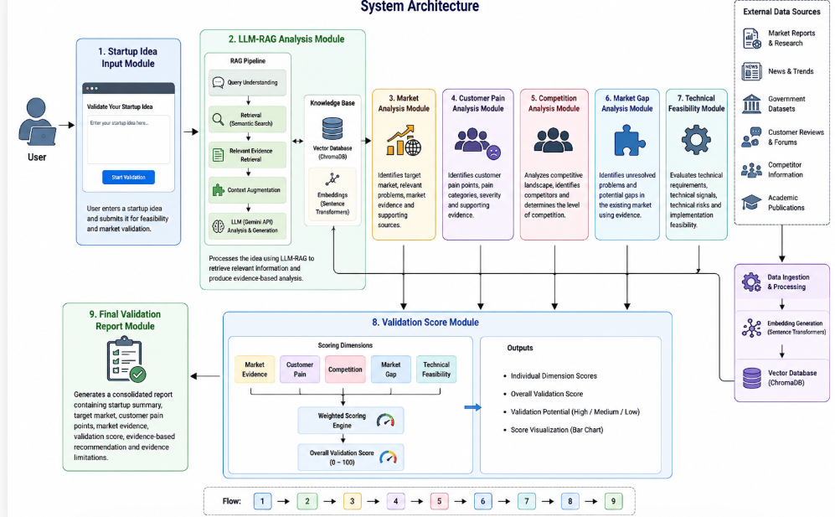
PROCESS MODEL USED WITH JUSTIFICATION
SDLC (Umbrella Model):

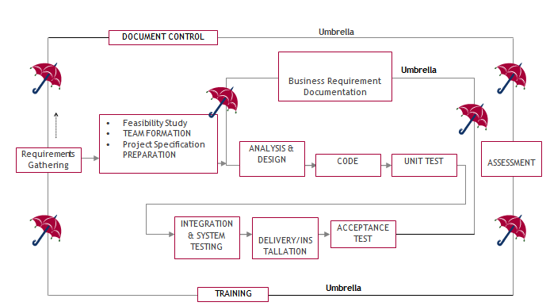

SDLC is nothing but Software Development Life Cycle. It is a standard which is used by software industry to develop good software.

Stages in SDLC:
- Requirement Gathering
- Analysis
- Designing
- Coding
- Testing
- Maintenance

Requirements Gathering stage:
The requirements gathering process takes as its input the goals identified in the high-level requirements section of the project plan. Each goal will be refined into a set of one or more requirements. These requirements define the major functions of the intended application, define operational data areas and reference data areas, and define the initial data entities. Major functions include critical processes to be managed, as well as mission critical inputs, outputs and reports. A user class hierarchy is developed and associated with these major functions, data areas, and data entities. Each of these definitions is termed a Requirement. Requirements are identified by unique requirement identifiers and, at minimum, contain a requirement title and textual description.

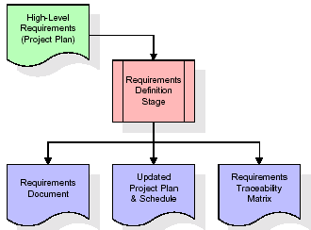

These requirements are fully described in the primary deliverables for this stage: the Requirements Document and the Requirements Traceability Matrix (RTM). The requirements document contains complete descriptions of each requirement, including diagrams and references to external documents as necessary. Note that detailed listings of database tables and fields are not included in the requirements document. The title of each requirement is also placed into the first version of the RTM, along with the title of each goal from the project plan. The purpose of the RTM is to show that the product components developed during each stage of the software development lifecycle are formally connected to the components developed in prior stages. In the requirements stage, the RTM consists of a list of high-level requirements, or goals, by title, with a listing of associated requirements for each goal, listed by requirement title. In this hierarchical listing, the RTM shows that each requirement developed during this stage is formally linked to a specific product goal. In this format, each requirement can be traced to a specific product goal, hence the term requirements traceability.

The outputs of the requirements definition stage include the requirements document, the RTM, and an updated project plan.
- Feasibility study is all about identification of problems in a project.
- No. of staff required to handle a project is represented as Team Formation, in this case only modules are individual tasks will be assigned to employees who are working for that project.
- Project Specifications are all about representing of various possible inputs submitting to the server and corresponding outputs along with reports maintained by administrator.

Analysis Stage:
The planning stage establishes a bird's eye view of the intended software product, and uses this to establish the basic project structure, evaluate feasibility and risks associated with the project, and describe appropriate management and technical approaches.

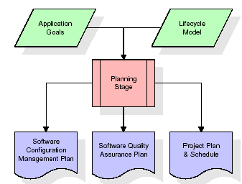

The most critical section of the project plan is a listing of high-level product requirements, also referred to as goals. All of the software product requirements to be developed during the requirements definition stage flow from one or more of these goals. The minimum information for each goal consists of a title and textual description, although additional information and references to external documents may be included. The outputs of the project planning stage are the configuration management plan, the quality assurance plan, and the project plan and schedule, with a detailed listing of scheduled activities for the upcoming Requirements stage, and high-level estimates of effort for the out stages.

Designing Stage:
The design stage takes as its initial input the requirements identified in the approved requirements document. For each requirement, a set of one or more design elements will be produced as a result of interviews, workshops, and/or prototype efforts. Design elements describe the desired software features in detail, and generally include functional hierarchy diagrams, screen layout diagrams, tables of business rules, business process diagrams, pseudo code, and a complete entity-relationship diagram with a full data dictionary. These design elements are intended to describe the software in sufficient detail that skilled programmers may develop the software with minimal additional input.
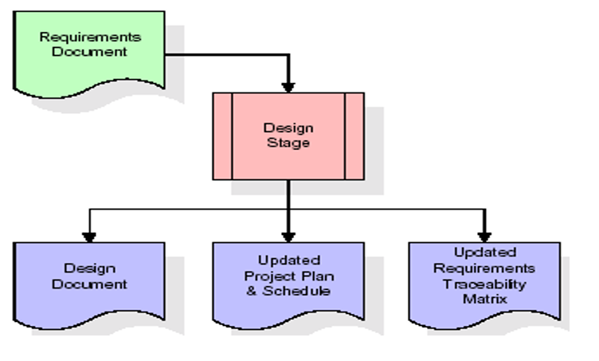
When the design document is finalized and accepted, the RTM is updated to show that each design element is formally associated with a specific requirement. The outputs of the design stage are the design document, an updated RTM, and an updated project plan.

Development (Coding) Stage:
The development stage takes as its primary input the design elements described in the approved design document. For each design element, a set of one or more software artifacts will be produced. Software artifacts include but are not limited to menus, dialogs, and data management forms, data reporting formats, and specialized procedures and functions. Appropriate test cases will be developed for each set of functionally related software artifacts, and an online help system will be developed to guide users in their interactions with the software.

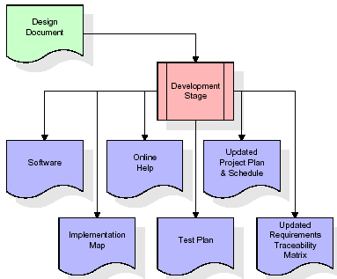

The RTM will be updated to show that each developed artifact is linked to a specific design element, and that each developed artifact has one or more corresponding test case items. At this point, the RTM is in its final configuration. The outputs of the development stage include a fully functional set of software that satisfies the requirements and design elements previously documented, an online help system that describes the operation of the software, an implementation map that identifies the primary code entry points for all major system functions, a test plan that describes the test cases to be used to validate the correctness and completeness of the software, an updated RTM, and an updated project plan.

Integration & Test Stage:
During the integration and test stage, the software artifacts, online help, and test data are migrated from the development environment to a separate test environment. At this point, all test cases are run to verify the correctness and completeness of the software. Successful execution of the test suite confirms a robust and complete migration capability. During this stage, reference data is finalized for production use and production users are identified and linked to their appropriate roles. The final reference data (or links to reference data source files) and production user list are compiled into the Production Initiation Plan.
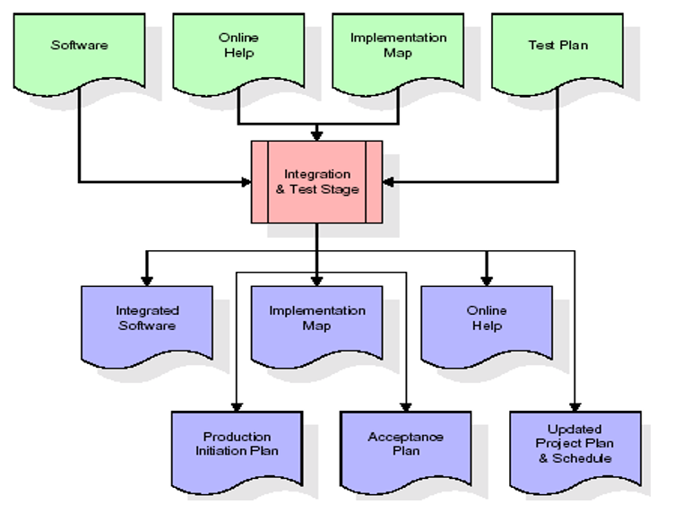
The outputs of the integration and test stage include an integrated set of software, an online help system, an implementation map, a production initiation plan that describes reference data and production users, an acceptance plan which contains the final suite of test cases, and an updated project plan.

- Installation & Acceptance Test:
During the installation and acceptance stage, the software artifacts, online help, and initial production data are loaded onto the production server. At this point, all test cases are run to verify the correctness and completeness of the software. Successful execution of the test suite is a prerequisite to acceptance of the software by the customer. After customer personnel have verified that the initial production data load is correct and the test suite has been executed with satisfactory results, the customer formally accepts the delivery of the software. The primary outputs of the installation and acceptance stage include a production application, a completed acceptance test suite, and a memorandum of customer acceptance of the software. Finally, the PDR enters the last of the actual labor data into the project schedule and locks the project as a permanent project record. At this point the PDR "locks" the project by archiving all software items, the implementation map, the source code, and the documentation for future reference.
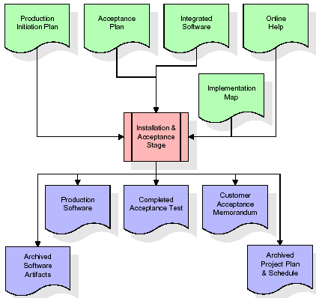

Maintenance:
Outer rectangle represents maintenance of a project, Maintenance team will start with requirement study, understanding of documentation later employees will be assigned work and they will undergo training on that particular assigned category. For this life cycle there is no end, it will be continued so on like an umbrella (no ending point to umbrella sticks).

Software Requirement Specification
Overall Description
A Software Requirements Specification (SRS) – a requirements specification for a software system is a complete description of the behaviour of a system to be developed. It includes a set of use cases that describe all the interactions the users will have with the software. In addition to use cases, the SRS also contains non-functional requirements. Non-functional requirements are requirements which impose constraints on the design or implementation (such as performance engineering requirements, quality standards, or design constraints). System requirements specification: A structured collection of information that embodies the requirements of a system. A business analyst, sometimes titled system analyst, is responsible for analysing the business needs of their clients and stakeholders to help identify business problems and propose solutions. Within the systems development lifecycle domain, the BA typically performs a liaison function between the business side of an enterprise and the information technology department or external service providers. Projects are subject to three sorts of requirements:
- Business requirements describe in business terms what must be delivered or accomplished to provide value.
- Product requirements describe properties of a system or product (which could be one of several ways to accomplish a set of business requirements.)
- Process requirements describe activities performed by the developing organization. For instance, process requirements could specify .Preliminary investigation examine project feasibility, the likelihood the system will be useful to the organization. The main objective of the feasibility study is to test the Technical, Operational and Economical feasibility for adding new modules and debugging old running system. All system is feasible if they are unlimited resources and infinite time. There are aspects in the feasibility study portion of the preliminary investigation:

- ECONOMIC FEASIBILITY
A system can be developed technically and that will be used if installed must still be a good investment for the organization. In the economic feasibility, the development cost in creating the system is evaluated against the ultimate benefit derived from the new systems. Financial benefits must equal or exceed the costs. The system is economically feasible. It does not require any addition hardware or software. Since the interface for this system is developed using the existing resources and technologies available at NIC, there is nominal expenditure and economic feasibility for certain.
- Operational Feasibility
Proposed projects are beneficial only if they can be turned out into information system. That will meet the organization’s operating requirements. Operational feasibility aspects of the project are to be taken as an important part of the project implementation. This system is targeted to be in accordance with the above-mentioned issues. Beforehand, the management issues and user requirements have been taken into consideration. So there is no question of resistance from the users that can undermine the possible application benefits. The well-planned design would ensure the optimal utilization of the computer resources and would help in the improvement of performance status.

- TECHNICAL FEASIBILITY
Earlier no system existed to cater to the needs of ‘Secure Infrastructure Implementation System’. The current system developed is technically feasible. It is a web-based user interface for audit workflow at NIC-CSD. Thus, it provides an easy access to. the users. The database’s purpose is to create, establish and maintain a workflow among various entities in order to facilitate all concerned users in their various capacities or roles. Permission to the users would be granted based on the roles specified. Therefore, it provides the technical guarantee of accuracy, reliability and security.

External Interface Requirements
User Interface
The user interface of this system is a user-friendly python Graphical User Interface.
Hardware Interfaces
The interaction between the user and the console is achieved through python capabilities.
Software Interfaces
The required software is python.

SYSTEM REQUIREMENT:
HARDWARE REQUIREMENTS:

Processor - Intel I3(min)
- Speed - 1.1 GHz
- RAM - 4GB (min)
- Hard Disk - 500GB (min)
SOFTWARE REQUIREMENTS:
- Operating system : Windows 10 (min)
- Coding Language : python 3.11 or above
- Web Framework : Streamlit

SYSTEM DESIGN
UML Diagram:
The Unified Modelling Language allows the software engineer to express an analysis model using the modelling notation that is governed by a set of syntactic semantic and pragmatic rules.
A UML system is represented using five different views that describe the system from distinctly different perspective. Each view is defined by a set of diagram, which is as follows.
  - User Model View
    - This view represents the system from the users perspective.
    - The analysis representation describes a usage scenario from the end-users perspective.
  - Structural Model view
    - In this model the data and functionality are arrived from inside the system.
    - This model view models the static structures.
- Behavioural Model View
It represents the dynamic of behavioural as parts of the system, depicting the interactions of collection between various structural elements described in the user model and structural model view.
- Implementation Model View
In this the structural and behavioural as parts of the system are represented as they are to be built.
- Environmental Model View
In this the structural and behavioural aspect of the environment in which the system is to be implemented are represented.
Class Diagram:
The class diagram is the main building block of object oriented modelling. It is used both for general conceptual modelling of the systematic of the application, and for detailed modelling translating the models into programming code. Class diagrams can also be used for data modelling. The classes in a class diagram represent both the main objects, interactions in the application and the classes to be programmed. In the diagram, classes are represented with boxes which contain three parts:
- The upper part holds the name of the class
- The middle part contains the attributes of the class
- The bottom part gives the methods or operations the class can take or undertake.

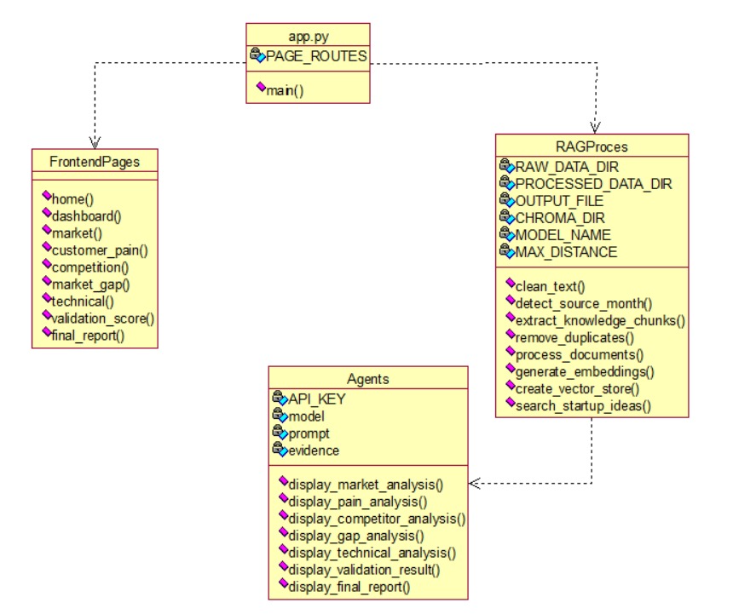

Use case Diagram:
A use case diagram at its simplest is a representation of a user's interaction with the system and depicting the specifications of a use case. A use case diagram can portray the different types of users of a system and the various ways that they interact with the system. This type of diagram is typically used in conjunction with the textual use case and will often be accompanied by other types of diagrams as well.

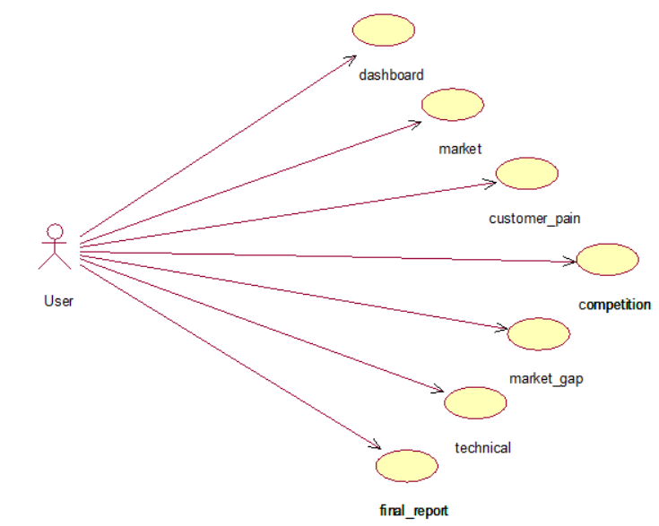

Sequence diagram:
A sequence diagram is a kind of interaction diagram that shows how processes operate with one another and in what order. It is a construct of a Message Sequence Chart. A sequence diagram shows object interactions arranged in time sequence. It depicts the objects and classes involved in the scenario and the sequence of messages exchanged between the objects needed to carry out the functionality of the scenario. Sequence diagrams are typically associated with use case realizations in the Logical View of the system under development. Sequence diagrams are sometimes called event diagrams, event scenarios, and timing diagrams.

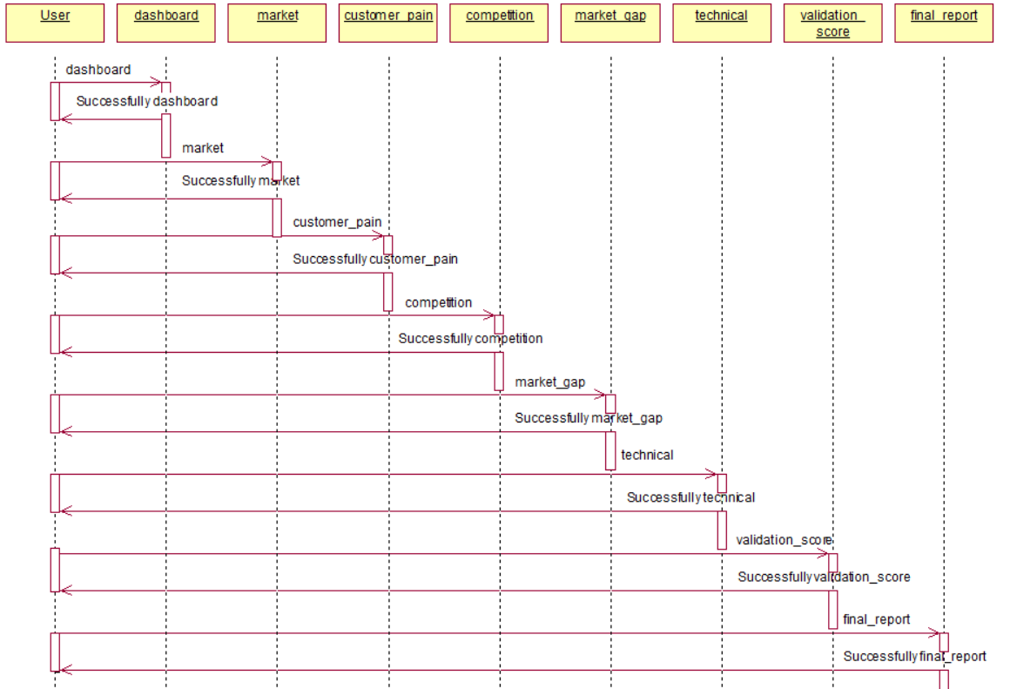

Collaboration diagram:
A collaboration diagram describes interactions among objects in terms of sequenced messages. Collaboration diagrams represent a combination of information taken from class, sequence, and use case diagrams describing both the static structure and dynamic behaviour of a system.

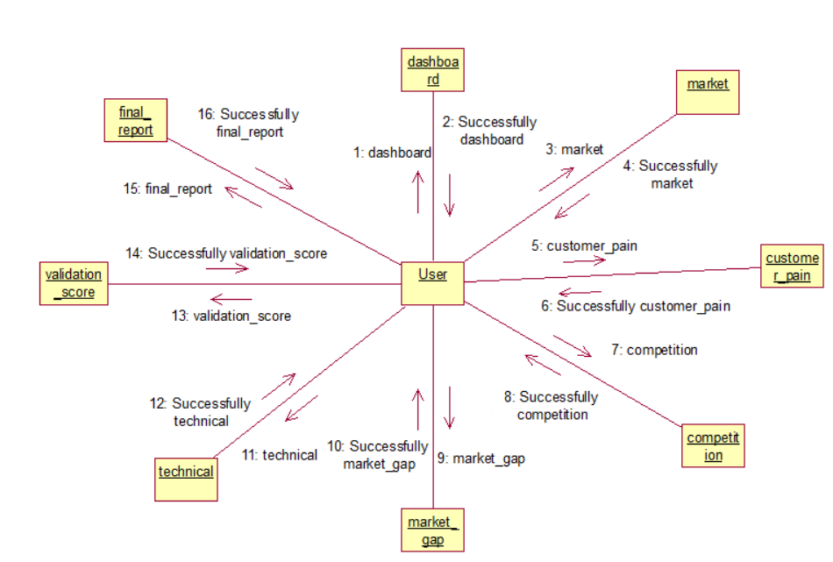

Component Diagram:
In the Unified Modelling Language, a component diagram depicts how components are wired together to form larger components and or software systems. They are used to illustrate the structure of arbitrarily complex systems.
Components are wired together by using an assembly connector to connect the required interface of one component with the provided interface of another component. This illustrates the service consumer - service provider relationship between the two components.

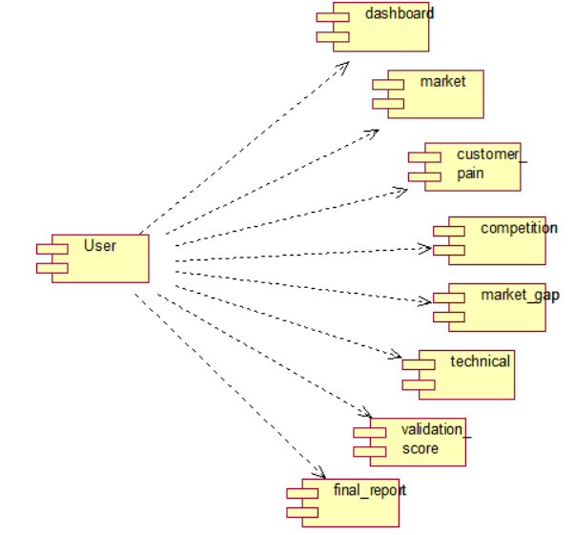

Deployment Diagram:
A deployment diagram in the Unified Modeling Language models the physical deployment of artifacts on nodes. To describe a web site, for example, a deployment diagram would show what hardware components ("nodes") exist (e.g., a web server, an application server, and a database server), what software components ("artifacts") run on each node (e.g., web application, database), and how the different pieces are connected (e.g. JDBC, REST, RMI).
The nodes appear as boxes, and the artifacts allocated to each node appear as rectangles within the boxes. Nodes may have sub nodes, which appear as nested boxes. A single node in a deployment diagram may conceptually represent multiple physical nodes, such as a cluster of database servers.

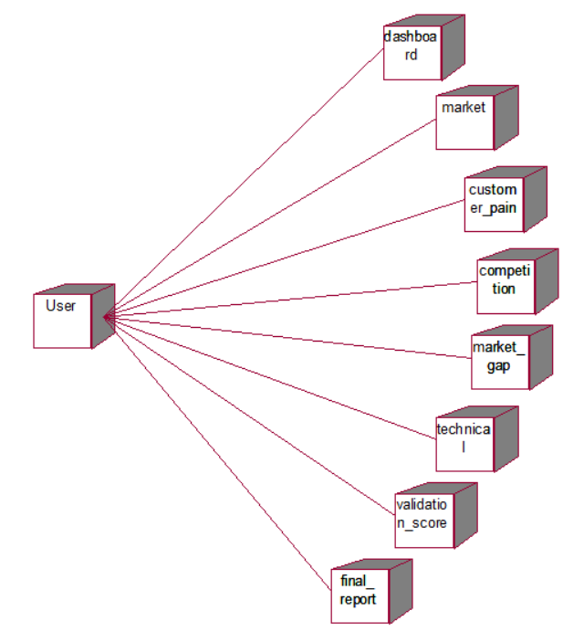
Activity Diagram:
Activity diagram is another important diagram in UML to describe dynamic aspects of the system. It is basically a flow chart to represent the flow form one activity to another activity. The activity can be described as an operation of the system. So the control flow is drawn from one operation to another. This flow can be sequential, branched or concurrent

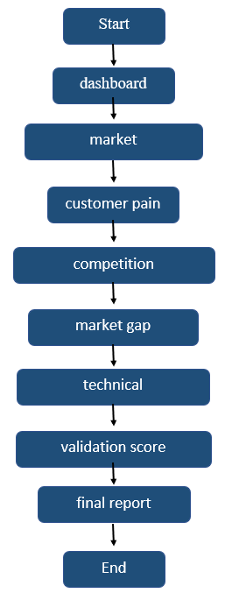

Data Flow Diagram:
Data flow diagrams illustrate how data is processed by a system in terms of inputs and outputs. Data flow diagrams can be used to provide a clear representation of any business function. The technique starts with an overall picture of the business and continues by analyzing each of the functional areas of interest. This analysis can be carried out in precisely the level of detail required. The technique exploits a method called top-down expansion to conduct the analysis in a targeted way.
As the name suggests, Data Flow Diagram (DFD) is an illustration that explicates the passage of information in a process. A DFD can be easily drawn using simple symbols. Additionally, complicated processes can be easily automated by creating DFDs using easy-to-use, free downloadable diagramming tools. A DFD is a model for constructing and analyzing information processes. DFD illustrates the flow of information in a process depending upon the inputs and outputs. A DFD can also be referred to as a Process Model. A DFD demonstrates business or technical process with the support of the outside data saved, plus the data flowing from the process to another and the end results.

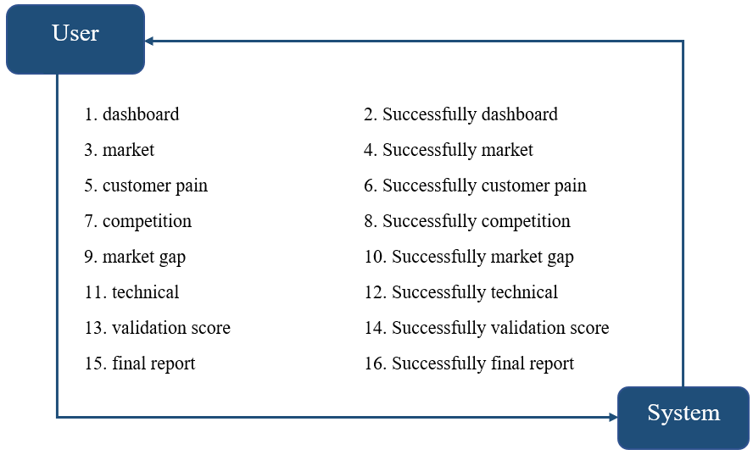

IMPLEMETATION
PYTHON
* One of the most popular languages is Python. Guido van Rossum released this language in 1991. Python is available on the Mac, Windows, and Raspberry Pi operating systems. The syntax of Python is simple and identical to that of English. When compared to Python, it was seen that the other language requires a few extra lines.
*It is an interpreter-based language because code may be run line by line after it has been written. This implies that rapid prototyping is possible across all platforms. Python is a big language with a free, binary-distributed interpreter standard library.
* It is inferior to maintenance that is conducted and is straightforward to learn. It is an object-oriented, interpreted programming language. It supports several different programming paradigms in addition to object-oriented programming, including functional and procedural programming.
* It supports several different programming paradigms in addition to object-oriented programming, including practical and procedural programming. Python is mighty while maintaining a relatively straightforward syntax. Classes, highly dynamic data types, modules, and exceptions are covered. Python can also be utilised by programmes that require programmable interfaces as an external language.
Here are some key features and characteristics of Python:
- Readability: Python emphasizes code readability with its clean and intuitive syntax. It uses indentation and whitespace to structure code blocks, making it easy to understand and maintain.
- Easy to Learn: Python's simplicity and readability make it an excellent choice for beginners. Its straightforward syntax and extensive documentation make it accessible for newcomers to programming.
- Interpreted Language: Python is an interpreted language, meaning that it doesn't need to be compiled before running. The Python interpreter reads and executes the code directly, making the development process faster and more interactive.
- Cross-platform Compatibility: Python is available for major operating systems like Windows, macOS, and Linux. This cross-platform compatibility allows developers to write code once and run it on different platforms without modifications.
- Large Standard Library: Python comes with a vast standard library that provides ready-to-use modules and functions for various tasks. It covers areas such as file I/O, networking, regular expressions, databases, and more, saving developers time and effort.
- Extensible and Modular: Python supports modular programming, enabling developers to organize code into reusable modules and packages. Additionally, Python allows integrating modules written in other languages, such as C or C++, providing flexibility and performance optimizations.
- Wide Range of Libraries and Frameworks: Python has a vibrant ecosystem with numerous third-party libraries and frameworks. These libraries, such as NumPy, pandas, TensorFlow, and Django, extend Python's capabilities for specific domains, making it a powerful tool for diverse applications.
- Object-Oriented: Python supports object-oriented programming (OOP) principles, allowing developers to create and work with classes and objects. OOP provides a structured approach to code organization, promoting code reuse and modularity.
- Dynamic Typing: Python is dynamically typed, meaning variable types are determined at runtime. Developers do not need to declare variable types explicitly, which enhances flexibility and simplifies code writing.
Installation
To install Python on your computer, follow these basic steps:
- Step 1: Visit the Python website Go to the official Python website at https://www.python.org/.
- Step 2: Select the operating system Choose the appropriate installer for your operating system. Python supports Windows, macOS, and various Linux distributions. Make sure to select the correct version that matches your operating system.
- Step 3: Check which version of Python is installed; if the 3.7.0 version is not there, uninstall it through the control panel and
- Step 4: Install Python 3.7.0 using Cmd.
- Step 5: Install the all libraries that required to run the project
- Step 6: Run
Python Features:
- Easy: Because Python is a more accessible and straightforward language, Python programming is easier to learn.
- Interpreted language: Python is an interpreted language;therefore it can be used to examine the code line by line and provide results.
- Open Source: Python is a free online programming language since it is open-source.
- Portable: Python is portable because the same code may be used on several computer standard
- libraries: Python offers a sizable library that we may utilize to create applications quickly.
- GUI: It stands for GUI (Graphical User Interface)
- Dynamical typed: Python is a dynamically typed language; therefore the type of the value will be determined at runtime.
Python IDLE
- Python IDLE offers a full-fledged file editor, which gives you the ability to write and execute Python programs from within this program. The built-in file editor also includes several features, like code completion and automatic indentation, that will speed up your coding workflow.
- Guido Van Rossum named Python after the British comedy group Monty Python while the name IDLE was chosen to pay tribute to Eric Idle, who was one of the Monty Python's founding members. IDLE comes bundled with the default implementation of the Python language since the 01.5. 2b1 release
- IDLE is used to execute statements similar to Python Shell. IDLE is used to create, modify, and execute Python code. IDLE provides a fully-featured text editor to write Python scripts and provides features like syntax highlighting, auto-completion, and smart indent.
- IDLE has two modes: interactive and script. We wrote our first program, “Hello, World!” in interactive mode. Interactive mode immediately returns the results of commands you enter into the shell. In script mode, you will write a script and then run it.
- The IDE Python IDLE is a good place to start as it helps you become familiar with the way Python works and understand its syntax. This IDE is good to start programming in Python due to its great debugger, but once you are fluent and start developing projects it is necessary to jump to another, more complete IDE.
- Python IDLE (Integrated Development and Learning Environment) is an interactive development environment included with the Python programming language. It provides a convenient way to write, execute, and debug Python code.
When you install Python, IDLE is typically installed along with it. To open IDLE, you can follow these steps:
- Open the command prompt (Windows) or terminal (macOS/Linux).
- Type "idle" and press Enter. Alternatively, you can specify the version with "idle3" or "idle2" for Python 3 or Python 2, respectively.
- Once IDLE is launched, you will see the Python shell, which is an interactive environment where you can type and execute Python code directly.
Here are some features and functionalities provided by Python IDLE:
- Editor: IDLE includes a text editor where you can write your Python code. It offers syntax highlighting, automatic indentation, and code completion to enhance your coding experience.
- Interactive Shell: The Python shell in IDLE allows you to execute Python code interactively. You can type commands, statements, or function calls directly in the shell, and Python will execute them immediately.
- Debugging: IDLE provides basic debugging capabilities to help you find and fix errors in your code. You can set breakpoints, step through code, inspect variables, and track the program's execution.
- Python Help: IDLE provides access to the Python documentation and built-in help. You can access the help menu to find information about Python modules, functions, classes, and more.
- Script Execution: In addition to the interactive shell, IDLE allows you to run Python scripts stored in files. You can write your code in the editor and execute it as a script to see the output or interact with the program.
- Customization: IDLE can be customized to suit your preferences. You can modify settings related to syntax highlighting, indentation, fonts, and more.
- Python IDLE serves as a beginner-friendly development environment and learning tool. It is suitable for writing small scripts, testing code snippets, experimenting with Python features, and learning the language's basics. However, for more advanced development projects, you may consider using other code editors or integrated development environments (IDEs) that provide additional features and better project management capabilities.
Libraries
In Python, libraries (also referred to as modules or packages) are collections of pre-written code that provide additional functionality and tools to extend the capabilities of the Python language. Libraries contain reusable code that developers can leverage to perform specific tasks without having to write everything from scratch.
Python libraries are designed to solve common problems, such as handling data, performing mathematical operations, interacting with databases, working with files, implementing networking protocols, creating graphical user interfaces (GUIs), and much more. They provide ready-to-use functions, classes, and methods that simplify complex operations and save development time.
Libraries in Python offer various advantages:
- Code Reusability
- Efficiency
- Collaboration
- Domain-Specific Functionality
- To use a Python library, you need to install it first.
There are some libraries following:
- Pandas:
Pandas are a Python computer language library for data analysis and manipulation. It offers a specific operation and data format for handling time series and numerical tables. It differs significantly from the release3-clause of the BSD license. It is a well-liked open-source of opinion that is utilized in machine learning and data analysis.
Pandas are a Python package providing fast, flexible, and expressive data structures designed to make working with “relational” or “labeled” data both easy and intuitive. It aims to be the fundamental high-level building block for doing practical, real-world data analysis in Python. Pandas are a Python library used for working with data sets.
- It has functions for analysing, cleaning, exploring, and manipulating data.
- The name "Pandas" has a reference to both "Panel Data", and "Python Data Analysis" and was created by Wes McKinney in 2008.
- Pandas allow us to analyse big data and make conclusions based on statistical theories.
- Pandas can clean messy data sets, and make them readable and relevant.
Relevant data is very important in data science. Pandas are a Python library for data analysis. Started by Wes McKinney in 2008 out of a need for a powerful and flexible quantitative analysis tool, pandas have grown into one of the most popular Python libraries. It has an extremely active community of contributors. The name is derived from the term "panel data", an econometrics term for data sets that include observations over multiple time periods for the same individuals. Its name is a play on the phrase "Python data analysis" itself.
- NumPy:
The NumPy Python library for multi-dimensional, big-scale matrices adds a huge number of high-level mathematical functions. It is possible to modify NumPy by utilizing a Python library. Along with line, algebra, and the Fourier transform operations, it also contains several matrices-related functions.
NumPy can be used to perform a wide variety of mathematical operations on arrays. It adds powerful data structures to Python that guarantee efficient calculations with arrays and matrices and it supplies an enormous library of high-level mathematical functions that operate on these arrays and matrices.
- NumPy is a Python library used for working with arrays.
- It also has functions for working in domain of linear algebra, Fourier transform, and matrices.
- NumPy was created in 2005 by Travis Oliphant. It is an open source project and you can use it freely.
- NumPy stands for Numerical Python.
- In Python we have lists that serve the purpose of arrays, but they are slow to process.
- NumPy aims to provide an array object that is up to 50x faster than traditional Python lists.
- The array object in NumPy is called ndarray, it provides a lot of supporting functions that make working with ndarray very easy.
- Arrays are very frequently used in data science, where speed and resources are very important.

- Matplotlib:
It is a multi-platform, array-based data visualization framework built to interact with the whole SciPy stack. MATLAB is proposed as an open-source alternative. Matplotlib is a Python extension and a cross-platform toolkit for graphical plotting and visualization.
Matplotlib is a popular Python library for creating static, animated, and interactive visualizations. It provides a flexible and comprehensive set of tools for generating plots, charts, histograms, scatter plots, and more. Matplotlib is widely used in various fields, including data analysis, scientific research, and data visualization.
Here are some key features and functionalities of the Matplotlib library:
- Plotting Functions
- Customization Options
- Multiple Interfaces
- Integration with NumPy and pandas
- Subplots and Figures:
- Saving and Exporting

- Seaborn:
Seaborn is one of the most powerful and user-friendly data visualization libraries in Python, built on top of Matplotlib. It is designed specifically for creating attractive, informative, and statistically meaningful graphics with minimal code. Because of its simplicity and strong integration with Pandas, Seaborn is widely used in data science, research, and analytics teams across industries. Many organizations rely on Seaborn for exploratory data analysis (EDA), trend identification, and statistical insights.
Seaborn provides a clean high-level interface for building advanced visualizations that would require much more effort with Matplotlib alone. It automatically handles themes, color palettes, statistical aggregations, and visual styling, making it an essential tool for anyone working with data in Python.
Below are some of the major features and capabilities of the Seaborn library:
Key Features of Seaborn:
- Beautiful and Customized Visualization Styles
- High-Level Plotting Functions
- Strong Integration with Pandas
- Built-In Statistical Support
- Advanced Multi-Plot Grids
- Easy Customization
- Ideal for Exploratory Data Analysis (EDA)

- Pickle:
Pickle is a built-in Python module that is used for object serialization and deserialization. Serialization (also called pickling) is the process of converting a Python object into a byte stream, and deserialization (also called unpickling) is the process of converting the byte stream back into a Python object. This allows Python objects to be saved to files, transferred over networks, or stored in databases while preserving their structure and data.
Pickle is especially useful when developers need to save the state of a program, store trained machine learning models, or share Python objects between different programs. The module supports many Python data types, including lists, dictionaries, tuples, sets, and even custom classes.
Some of the key features of Pickle include:
- Serialization of Python Objects: Convert complex objects into a byte stream for storage or transmission.
- Deserialization: Reconstruct Python objects from stored or transmitted byte streams.
- Support for Custom Classes: Objects of user-defined classes can also be pickled.
- Integration: Easily used for saving data structures, caching, or persisting models in machine learning applications.
- File Operations: Works with file objects to save and load data conveniently.
While Pickle is very flexible, it also has some limitations. Pickled data is Python-specific and may not be compatible with other programming languages. Additionally, unpickling data from untrusted sources is unsafe, as it can execute arbitrary code, leading to security risks.
Pickle is included in the Python Standard Library, so it requires no additional installation. Developers use it widely for temporary storage of Python objects, prototyping, and saving intermediate results during computations.

Sample Code:
app.py
"""
Startup Validation Engine — main entry point.

Run with: streamlit run app.py
"""

import streamlit as st

from frontend.session_state import initialize_session
from frontend.styles import apply_styles
from frontend.components.sidebar import render_sidebar

from frontend.pages import (
home,
dashboard,
market,
customer_pain,
competition,
market_gap,
technical,
validation_score,
final_report,
)

# Maps each sidebar page name to the function that renders it.
PAGE_ROUTES = {
"Home": home.show,
"Dashboard": dashboard.show,
"Market Analysis": market.show,
"Customer Pain": customer_pain.show,
"Competition": competition.show,
"Market Gap": market_gap.show,
"Technical Feasibility": technical.show,
"Validation Score": validation_score.show,
"Final Report": final_report.show,
}

def main():

st.set_page_config(
page_title="LLM-RAG Based Startup Idea Feasibility and Market Validation Engine",
page_icon="🚀",
layout="wide",
initial_sidebar_state="expanded",
)

initialize_session()
apply_styles()
render_sidebar()

current_page = st.session_state.get("current_page", "Home")

if current_page not in PAGE_ROUTES:
st.session_state.current_page = "Home"
st.rerun()

render_current_page = PAGE_ROUTES[current_page]
render_current_page()

if __name__ == "__main__":
main() _ == '__main__':
app.run()

TESTING
Implementation and Testing:
Implementation is one of the most important tasks in project is the phase in which one has to be cautions because all the efforts undertaken during the project will be very interactive. Implementation is the most crucial stage in achieving successful system and giving the users confidence that the new system is workable and effective. Each program is tested individually at the time of development using the sample data and has verified that these programs link together in the way specified in the program specification. The computer system and its environment are tested to the satisfaction of the user.

Implementation
The implementation phase is less creative than system design. It is primarily concerned with user training, and file conversion. The system may be requiring extensive user training. The initial parameters of the system should be modifies as a result of a programming. A simple operating procedure is provided so that the user can understand the different functions clearly and quickly. The different reports can be obtained either on the inkjet or dot matrix printer, which is available at the disposal of the user. The proposed system is very easy to implement. In general implementation is used to mean the process of converting a new or revised system design into an operational one.

Testing
Testing is the process where the test data is prepared and is used for testing the modules individually and later the validation given for the fields. Then the system testing takes place which makes sure that all components of the system property functions as a unit. The test data should be chosen such that it passed through all possible condition. Actually, testing is the state of implementation which aimed at ensuring that the system works accurately and efficiently before the actual operation commence. The following is the description of the testing strategies, which were carried out during the testing period.

System Testing
Testing has become an integral part of any system or project especially in the field of information technology. The importance of testing is a method of justifying, if one is ready to move further, be it to be check if one is capable to with stand the rigors of a particular situation cannot be underplayed and that is why testing before development is so critical. When the software is developed before it is given to user to use the software must be tested whether it is solving the purpose for which it is developed. This testing involves various types through which one can ensure the software is reliable. The program was tested logically and pattern of execution of the program for a set of data are repeated. Thus, the code was exhaustively checked for all possible correct data and the outcomes were also checked.

Module Testing
To locate errors, each module is tested individually. This enables us to detect error and correct it without affecting any other modules. Whenever the program is not satisfying the required function, it must be corrected to get the required result. Thus, all the modules are individually tested from bottom up starting with the smallest and lowest modules and proceeding to the next level. Each module in the system is tested separately. For example, the job classification module is tested separately. This module is tested with different job and its approximate execution time and the result of the test is compared with the results that are prepared manually. The comparison shows that the results proposed system works efficiently than the existing system. Each module in the system is tested separately. In this system the resource classification and job scheduling modules are tested separately and their corresponding results are obtained which reduces the process waiting time.

Integration Testing
After the module testing, the integration testing is applied. When linking the modules there may be chance for errors to occur, these errors are corrected by using this testing. In this system all modules are connected and tested. The testing results are very correct. Thus, the mapping of jobs with resources is done correctly by the system.

Acceptance Testing
When that user fined no major problems with its accuracy, the system passers through a final acceptance test. This test confirms that the system needs the original goals, objectives and requirements established during analysis without actual execution which elimination wastage of time and money acceptance tests on the shoulders of users and management, it is finally acceptable and ready for the operation

ID | Module | Test Case | Steps | Expected Result | Status | Priority
01 | Startup Idea Input Module | Validate Startup Idea Input | Enter a startup idea and submit it for validation. | Startup idea is accepted successfully and validation process starts. | Pass | High
02 | LLM-RAG Analysis Module | Validate LLM-RAG Analysis | Process the submitted startup idea using the LLM-RAG pipeline. | Relevant information is retrieved and evidence-based analysis is generated successfully. | Pass | High
03 | Market Analysis Module | Validate Market Analysis | Analyze the submitted startup idea for market information. | Target market, relevant problems, market evidence, and supporting sources are identified successfully. | Pass | High
04 | Customer Pain Analysis Module | Validate Customer Pain Analysis | Analyze the target market for customer pain points. | Customer pain points, categories, severity, and supporting evidence are identified successfully. | Pass | High
05 | Competition Analysis Module | Validate Competition Analysis | Analyze the competitive landscape for the startup idea. | Relevant competitors and competitive strength are identified successfully. | Pass | High
06 | Market Gap Analysis Module | Validate Market Gap Analysis | Analyze retrieved evidence for unresolved market problems. | Potential market gaps and unresolved problems are identified successfully. | Pass | High
07 | Technical Feasibility Module | Validate Technical Feasibility | Evaluate the technical requirements and risks of the startup idea. | Technical requirements, signals, risks, and feasibility status are identified successfully. | Pass | High
08 | Validation Score Module | Validate Validation Score | Calculate the score using market evidence, customer pain, competition, market gap, and technical feasibility. | Individual scores and overall validation score are calculated and displayed successfully. | Pass | High
09 | Final Validation Report Module | Validate Final Report | Generate the final validation report using the analyzed results. | Consolidated report containing startup summary, target market, customer pain points, market evidence, score, recommendation, and limitations is generated successfully. | Pass | High

SCREENSHOTS:

To run the project, double click on run.bat button to start the server and open the application.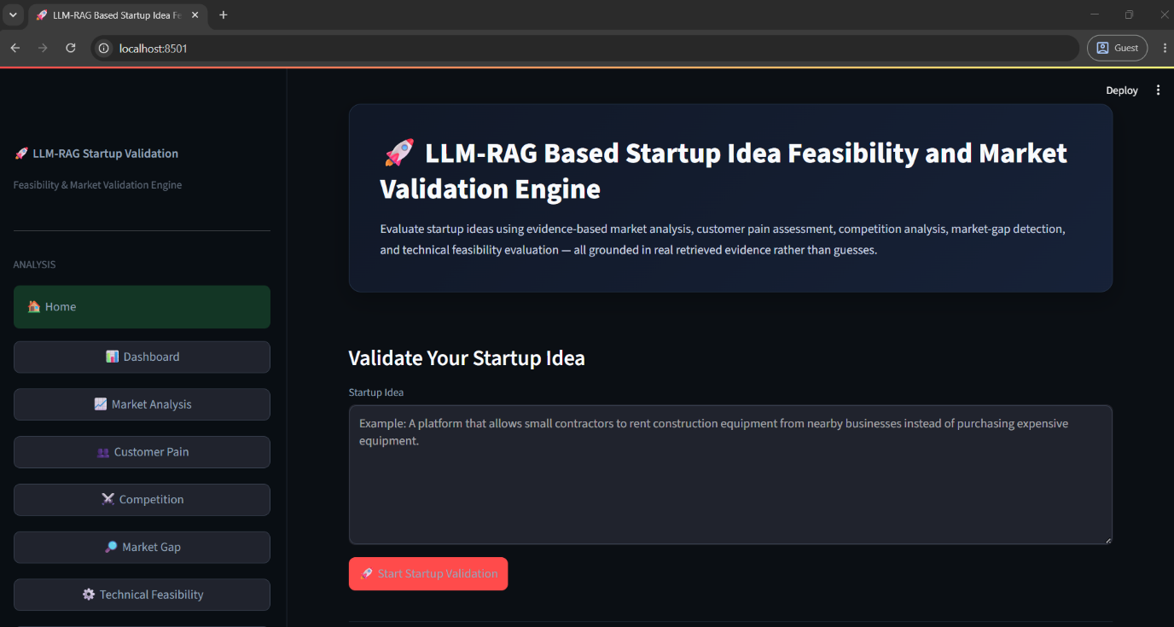
In the above screen the LLM-RAG Based Startup Idea Feasibility and Market Validation Engine home page is displayed. The user can enter a startup idea in the provided text area and click on the Start Validation button to analyze the startup idea.
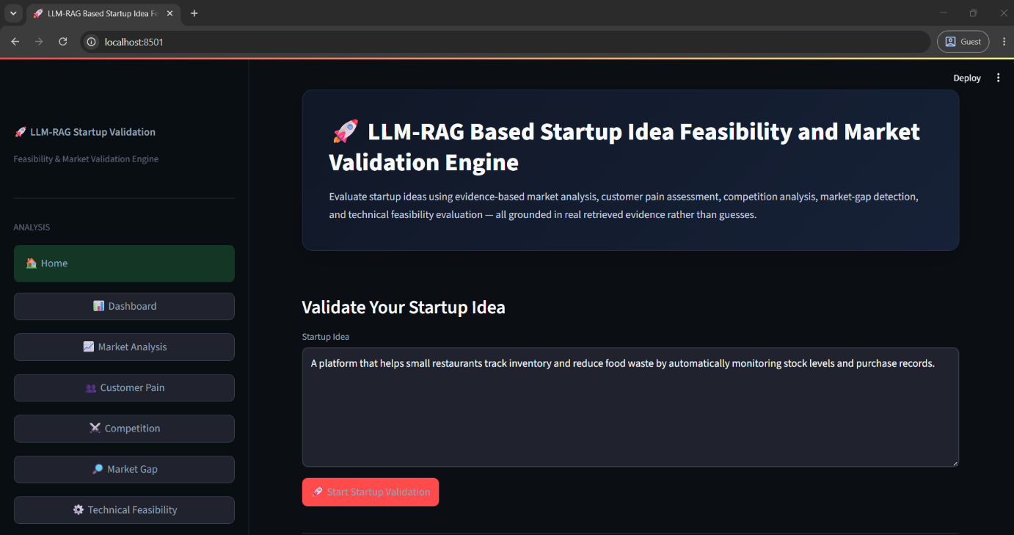
In the above screen another startup idea is entered in the Validate Your Startup Idea section and the user can start the validation process to generate market and feasibility analysis.
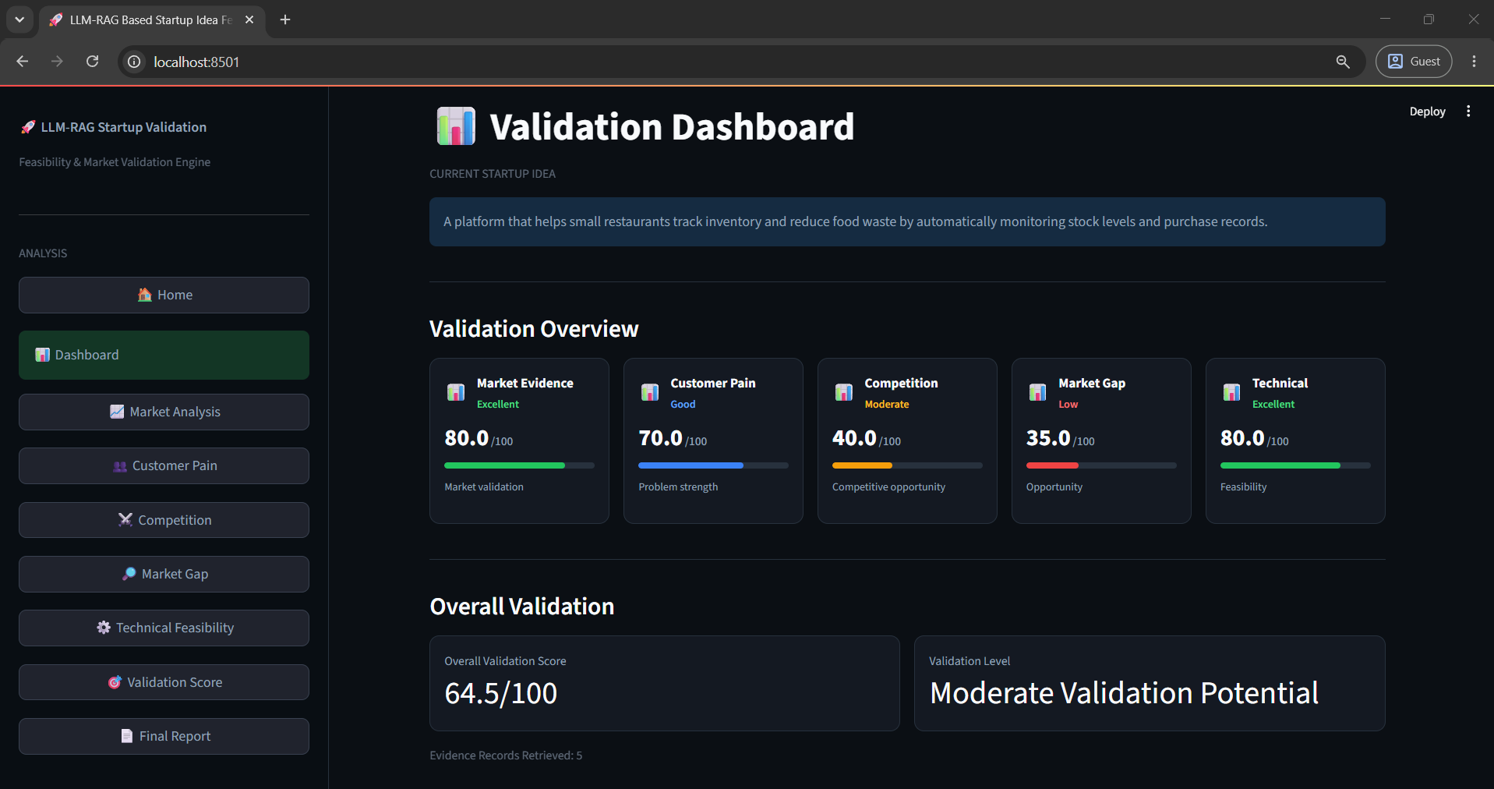
In the above screen the Validation Dashboard displays the overall startup validation results. It shows different validation dimensions such as Market Evidence, Customer Pain, Competition, Market Gap and Technical Feasibility, along with their individual scores and an overall validation score.
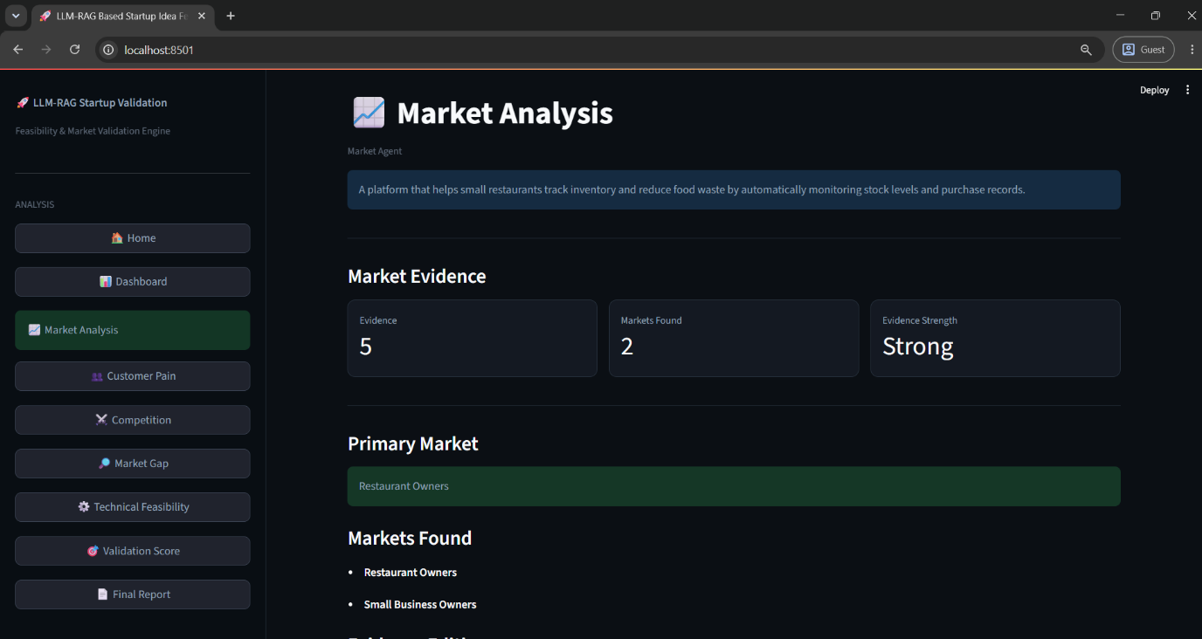
In the above screen the Market Analysis page displays market evidence identified for the submitted startup idea. It shows the number of evidence items, market sources and evidence strength, along with the identified primary market and markets found.
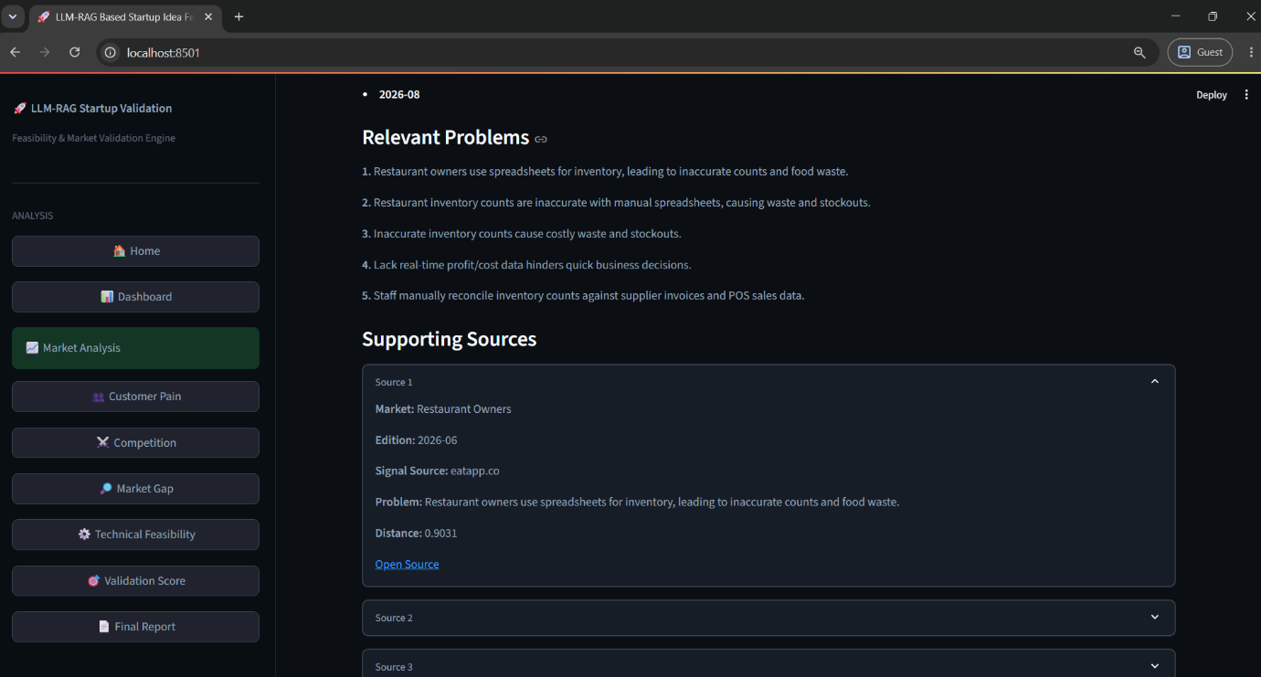
In the above screen the system displays Relevant Problems and Supporting Sources identified through the RAG-based analysis. The user can expand the available source sections to view the supporting evidence used for validation.
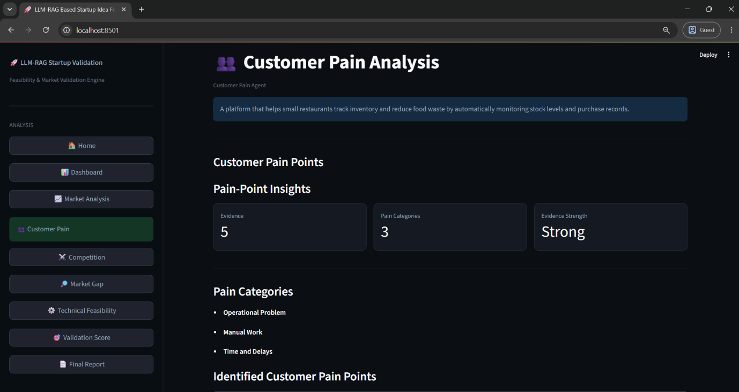
In the above screen the Customer Pain Analysis page displays identified customer pain points. It provides pain-point insights including the number of pain points, average severity and evidence strength, along with different pain categories.
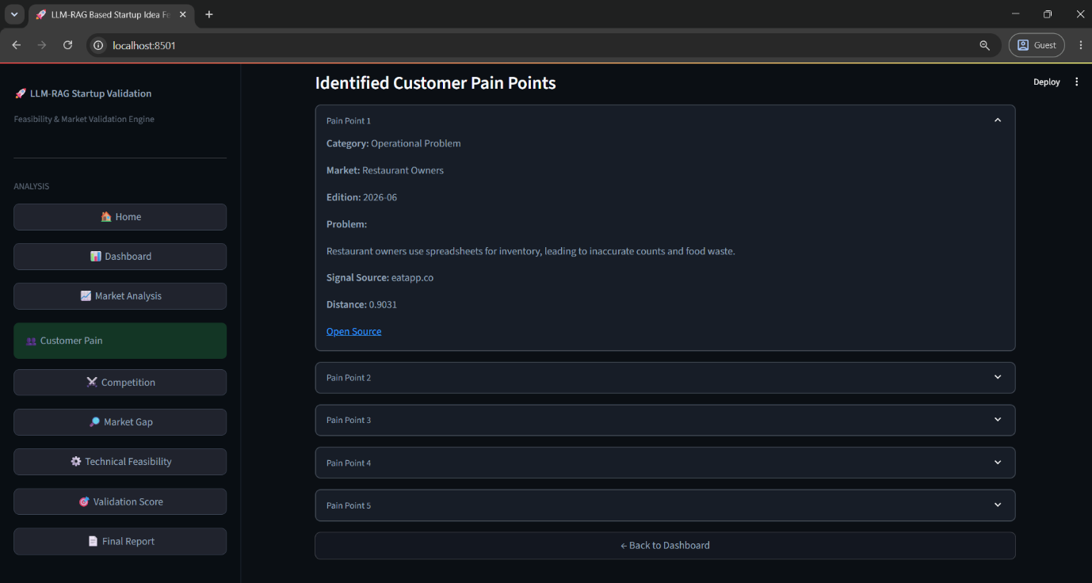
In the above screen the system displays the Identified Customer Pain Points in expandable sections. Each section provides details such as the category, market evidence, problem description and supporting source information.
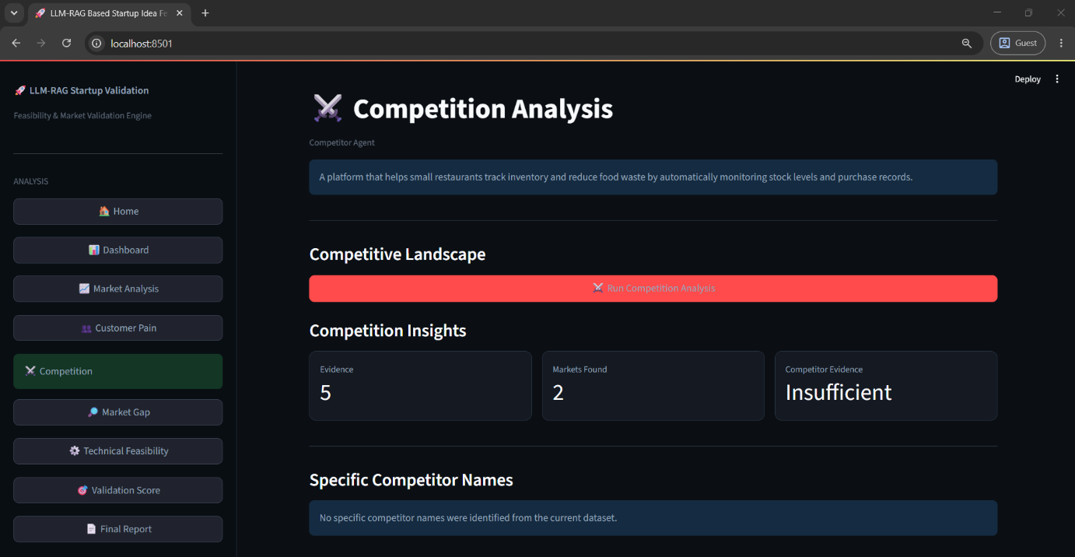
In the above screen the Competition Analysis page displays the competitive landscape and competition insights. It shows the number of competitors, market level and competitive strength, along with specific competitor information when available.
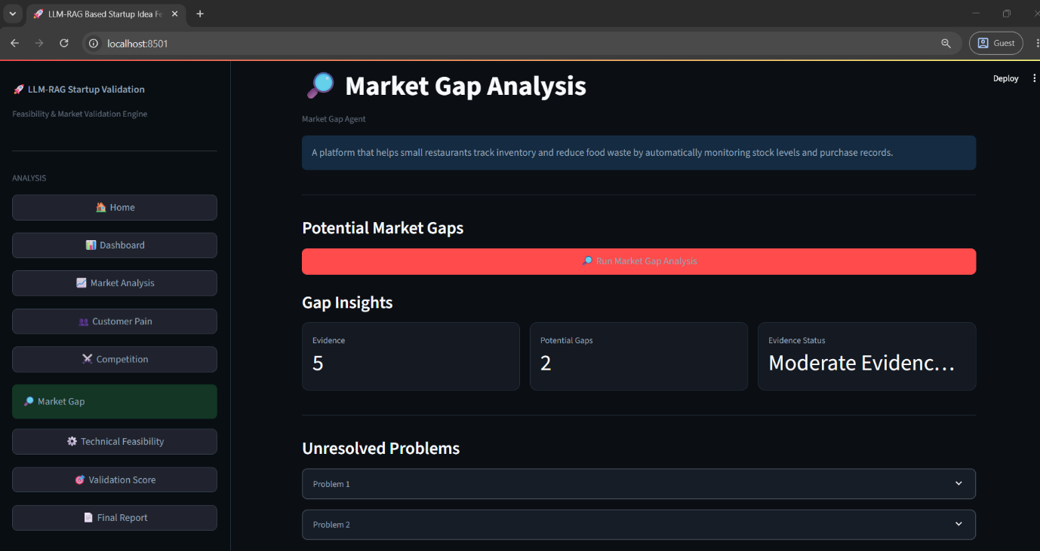
In the above screen the Market Gap Analysis page identifies potential gaps in the target market. It displays gap insights including the number of gaps, evidence level and evidence strength, followed by unresolved problems related to the startup idea.
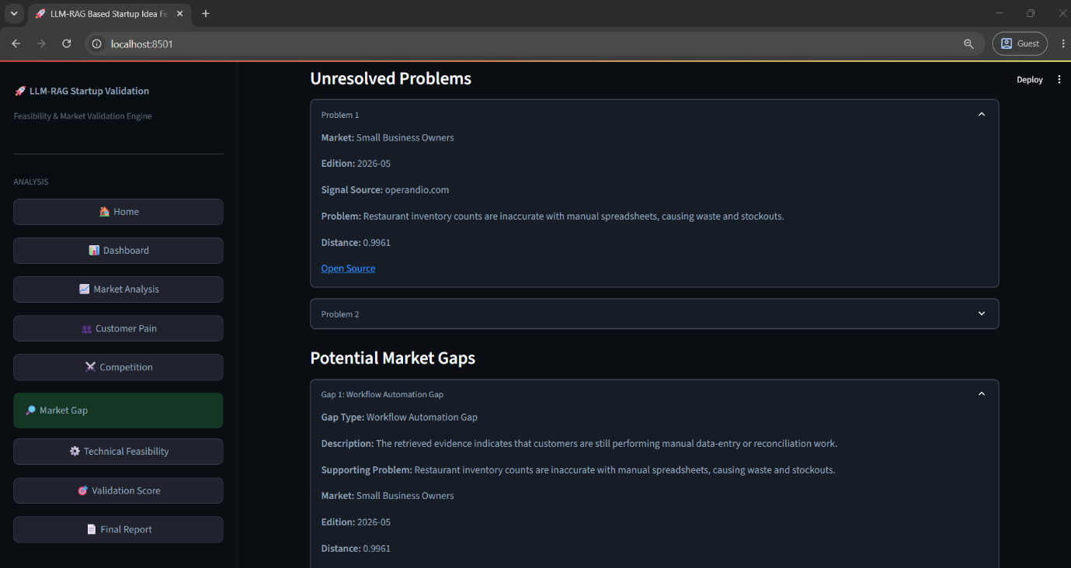
In the above screen the system displays detailed Unresolved Problems and Potential Market Gaps. The expandable sections provide descriptions of identified problems, market evidence, source information and the corresponding opportunity areas.
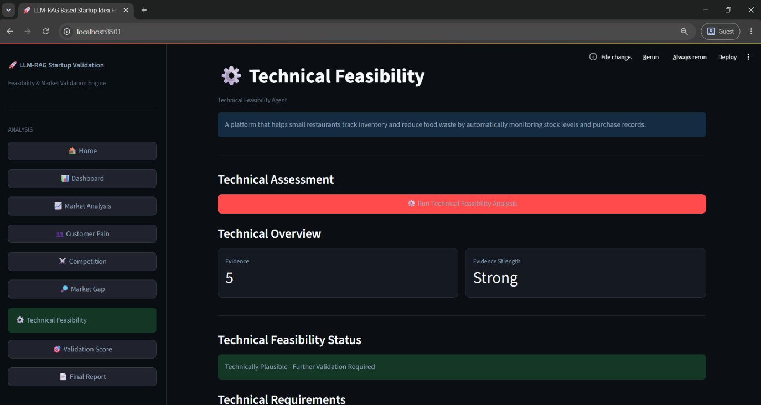
In the above screen the Technical Feasibility page presents the technical assessment of the startup idea. It displays technical overview information, evidence strength and the technical feasibility status of the proposed idea.
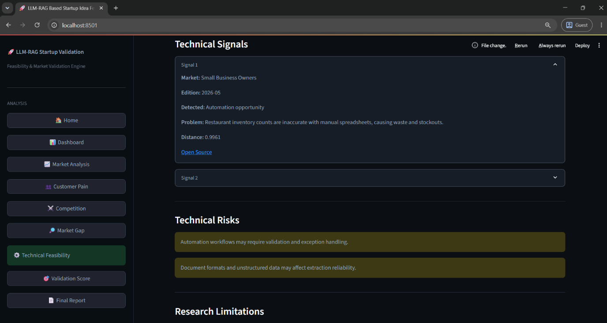
In the above screen the system displays Technical Signals, Technical Risks and research-related limitations. The technical signals provide supporting evidence, while the highlighted risk sections show potential technical concerns identified during analysis.
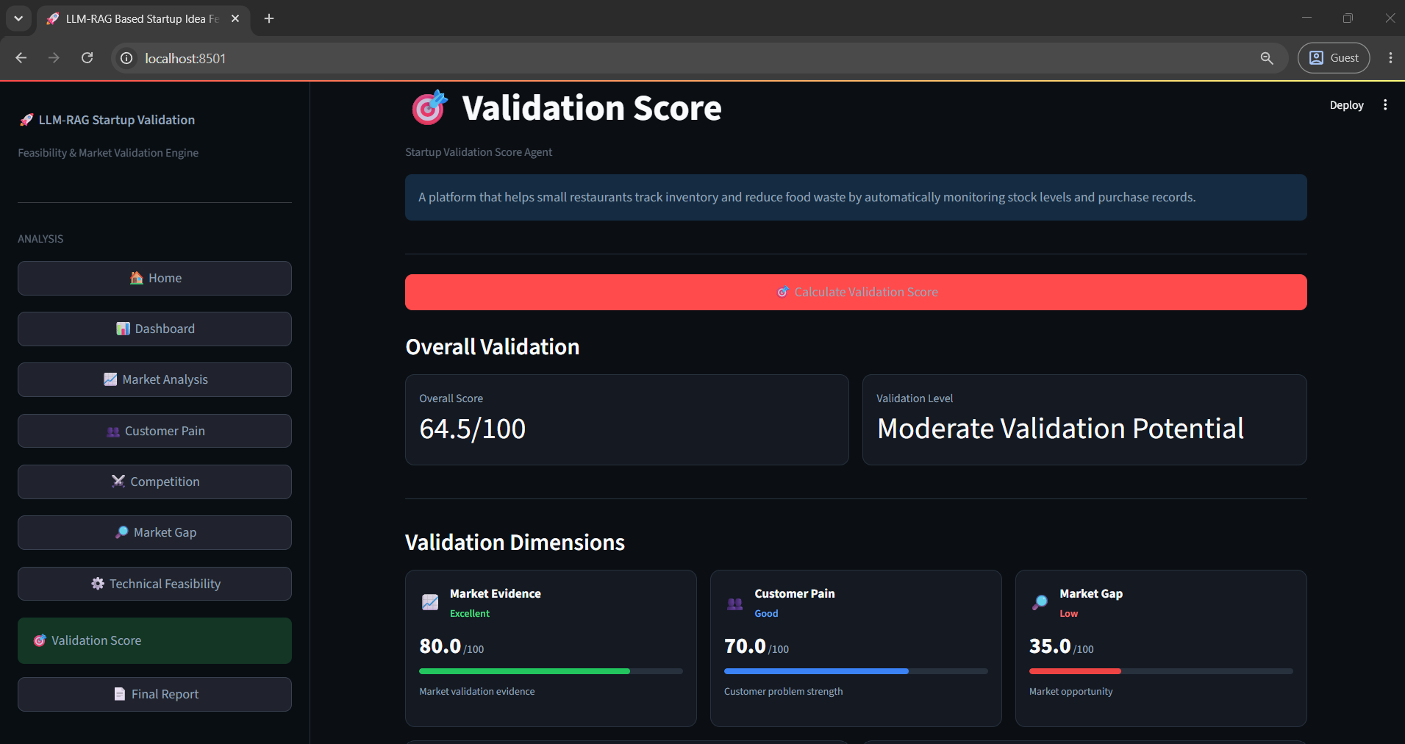
In the above screen the Validation Score page displays the overall validation score and validation potential. It also presents individual validation dimensions such as Market Evidence, Customer Pain and Market Gap with their respective scores.
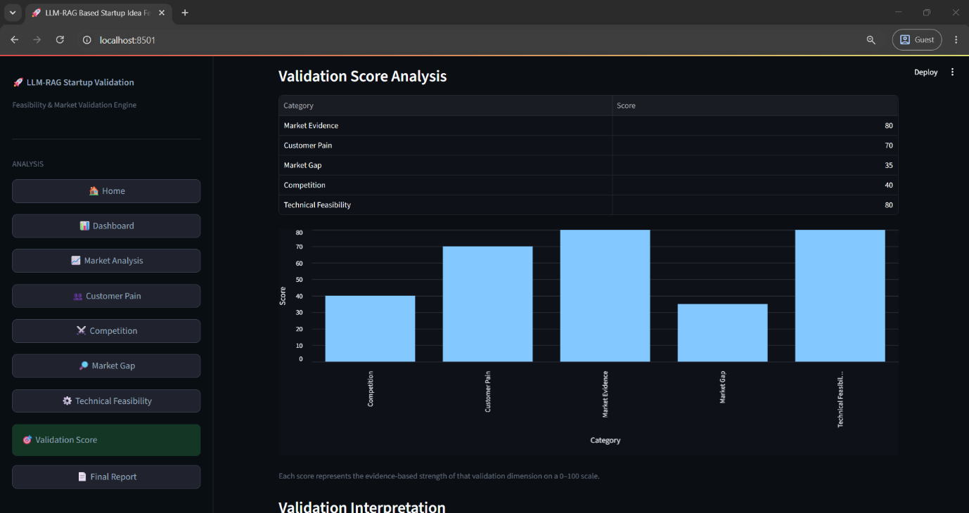
In the above screen the Validation Score Analysis displays a graphical comparison of the different validation dimensions. The bar chart provides a visual representation of the scores obtained for the startup idea.
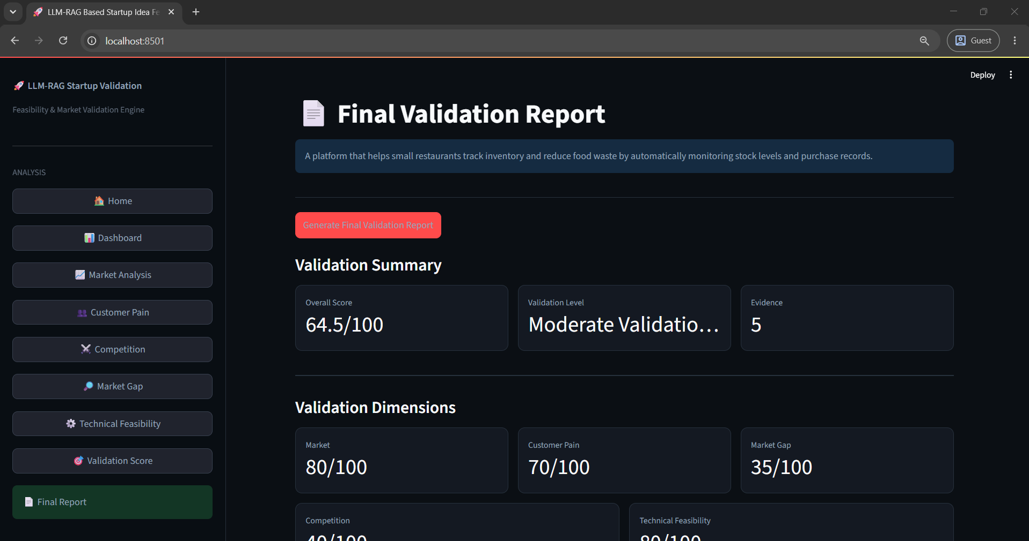
In the above screen the Final Validation Report provides a consolidated summary of the startup analysis. It displays the overall score, validation status and number of identified items along with individual validation dimension scores.
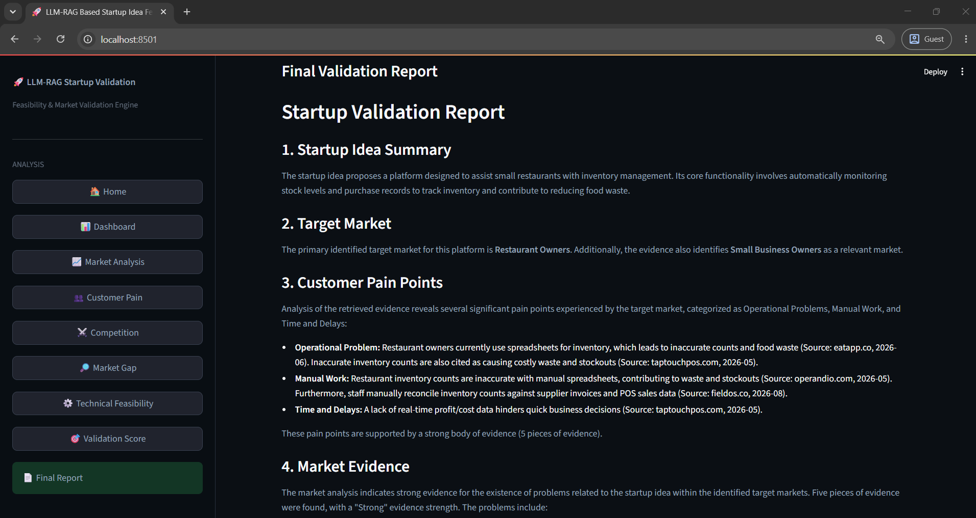
In the above screen the Startup Validation Report provides detailed findings including the Startup Idea Summary, Target Market, Customer Pain Points and Market Evidence generated from the analysis.

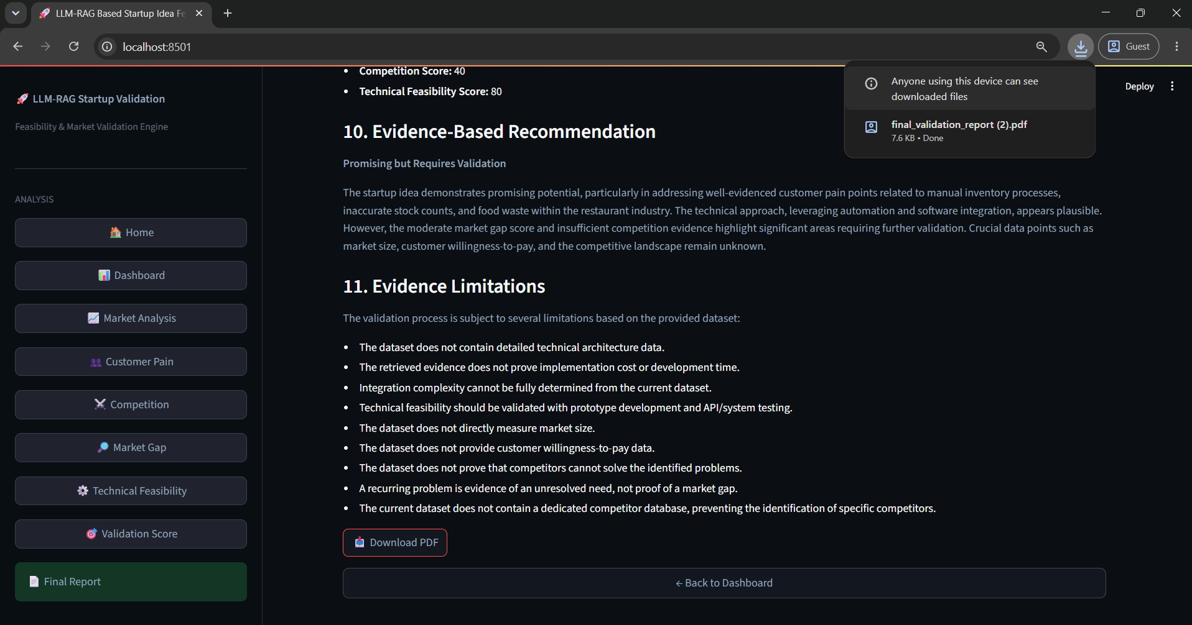
In the above screen the final section of the Startup Validation Report presents the Evidence-Based Recommendation and Evidence Limitations. The recommendation is generated using the analyzed evidence, while the limitations section describes the constraints of the available validation evidence.
CONCLUSION:

The proposed LLM-RAG Based Startup Idea Feasibility and Market Validation Engine provides an intelligent approach for evaluating startup ideas by combining Large Language Models, Retrieval-Augmented Generation, semantic retrieval, multi-dimensional analysis, and quantitative scoring. The system addresses several limitations of conventional startup evaluation approaches, particularly dependence on historical information, time-consuming manual research, limited customer pain-point analysis, and lack of transparent evidence-based recommendations.
The developed system accepts a startup idea through a web-based interface and processes it through an LLM-RAG pipeline. Relevant evidence is retrieved and supplied to the language model for grounded analysis. The implementation uses Sentence Transformers and ChromaDB for evidence retrieval and a Gemini API for LLM-based analysis.
The system evaluates multiple dimensions, including market evidence, customer pain, competition, market gaps, and technical feasibility. It presents individual scores and an overall validation score through a dashboard, followed by a consolidated validation report. The final report also includes evidence-based recommendations and evidence limitations, making the output more transparent and useful for decision-making.
Overall, the system demonstrates how LLM and RAG technologies can be applied to preliminary startup market validation. By combining retrieved evidence with structured analysis and scoring, the proposed framework can reduce the effort required for initial research and help entrepreneurs identify promising opportunities, customer problems, competitive challenges, market gaps, and technical concerns. However, the generated assessment should be treated as decision support rather than a guarantee of startup success, since real-world validation through customer interaction, prototype testing, financial analysis, and expert evaluation remains necessary.

FUTURE SCOPE
- Integration of More Real-Time Data Sources:
The system can be extended to continuously collect information from additional business databases, government portals, industry reports, news platforms, product-review websites, and public market sources. This would improve the freshness and breadth of retrieved evidence.
- Advanced Competitor and Market Monitoring:
Future versions can continuously monitor competitor product launches, pricing changes, new features, funding activities, customer reviews, and market movements. This could help identify emerging threats and opportunities automatically.
- Financial Feasibility and Revenue Prediction:
The framework can be extended with financial analysis modules for estimating startup costs, pricing strategies, revenue potential, break-even periods, customer acquisition costs, and other business metrics.
- Improved Multi-Agent and Predictive Analysis:
More specialized AI agents can be introduced for financial analysis, legal and regulatory analysis, technology assessment, customer segmentation, and business-model evaluation. Historical validation results could also be used to develop predictive models for improving feasibility scoring.
- Continuous Validation and Personalized Recommendations:
Future systems can maintain a continuously updated knowledge base and automatically reassess startup ideas as market conditions change. Personalized recommendations could then be generated for different users, industries, locations, and startup stages.

REFERENCES:
[1] Vaswani, A., Shazeer, N., Parmar, N., Uszkoreit, J., Jones, L., Gomez, A. N., Kaiser, Ł., & Polosukhin, I. (2017). Attention Is All You Need. Advances in Neural Information Processing Systems (NeurIPS), 30.
[2] Devlin, J., Chang, M. W., Lee, K., & Toutanova, K. (2019). BERT: Pre-training of Deep Bidirectional Transformers for Language Understanding. Proceedings of NAACL-HLT, 4171–4186.
[3] Brown, T. B., et al. (2020). Language Models are Few-Shot Learners. Advances in Neural Information Processing Systems (NeurIPS), 33.
[4] Lewis, P., Perez, E., Piktus, A., et al. (2020). Retrieval-Augmented Generation for Knowledge-Intensive NLP Tasks. Advances in Neural Information Processing Systems (NeurIPS), 33.
[5] Reimers, N., & Gurevych, I. (2019). Sentence-BERT: Sentence Embeddings using Siamese BERT-Networks. Proceedings of EMNLP-IJCNLP, 3982–3992.
[6] Gao, Y., Xiong, Y., Gao, X., et al. (2023). Retrieval-Augmented Generation for Large Language Models: A Survey. arXiv preprint arXiv:2312.10997.
[7] Ouyang, L., Wu, J., Jiang, X., et al. (2022). Training Language Models to Follow Instructions with Human Feedback. Advances in Neural Information Processing Systems (NeurIPS), 35.
[8] Yao, S., Zhao, J., Yu, D., et al. (2023). ReAct: Synergizing Reasoning and Acting in Language Models. International Conference on Learning Representations (ICLR).
[9] Liu, N. F., Lin, K., Hewitt, J., Paranjape, A., Bevilacqua, M., Petroni, F., & Liang, P. (2024). Lost in the Middle: How Language Models Use Long Contexts. Transactions of the Association for Computational Linguistics.
[10] Park, J. S., O'Brien, J. C., Cai, C. J., Morris, M. R., Liang, P., & Bernstein, M. S. (2023). Generative Agents: Interactive Simulacra of Human Behavior. Proceedings of the 36th Annual ACM Symposium on User Interface Software and Technology (UIST).
[11] Wu, Q., Bansal, G., Zhang, J., et al. (2024). AutoGen: Enabling Next-Gen LLM Applications via Multi-Agent Conversation. Proceedings of the Conference on Language Modeling (COLM).
[12] Wang, L., Ma, C., Feng, X., et al. (2023). A Survey on Large Language Model based Autonomous Agents. arXiv preprint arXiv:2308.11432.
[13] Arrieta, A. B., Díaz-Rodríguez, N., Del Ser, J., et al. (2020). Explainable Artificial Intelligence (XAI): Concepts, Taxonomies, Opportunities and Challenges toward Responsible AI. Information Fusion, 58, 82–115.
[14] Ries, E. (2011). The Lean Startup: How Today's Entrepreneurs Use Continuous Innovation to Create Radically Successful Businesses. Crown Business.
[15] Blank, S., & Dorf, B. (2012). The Startup Owner's Manual: The Step-by-Step Guide for Building a Great Company. K&S Ranch.
[16] Osterwalder, A., & Pigneur, Y. (2010). Business Model Generation: A Handbook for Visionaries, Game Changers, and Challengers. John Wiley & Sons.
[17] Rogers, E. M. (2003). Diffusion of Innovations (5th ed.). Free Press.
[18] Davis, F. D. (1989). Perceived Usefulness, Perceived Ease of Use, and User Acceptance of Information Technology. MIS Quarterly, 13(3), 319–340.
[19] Christensen, C. M., Hall, T., Dillon, K., & Duncan, D. S. (2016). Competing Against Luck: The Story of Innovation and Customer Choice. HarperBusiness.
[20] Moore, G. A. (2014). Crossing the Chasm: Marketing and Selling High-Tech Products to Mainstream Customers (3rd ed.). HarperBusiness.

